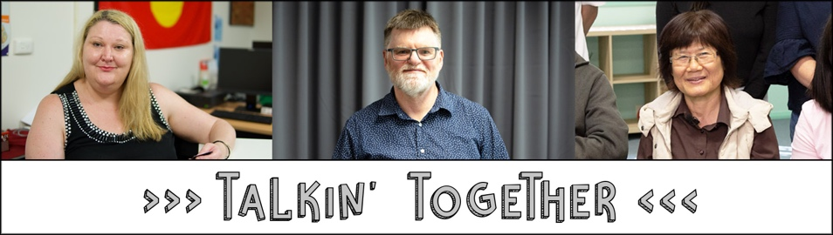
TnT Co-production- The process
(from independent TnT evaluation, Dec 2018)
Partnership | Co-production process
Council for Intellectual Disability | •Met two days per week for four to six weeks  •Reviewed existing Fair Trading information to identify information was hard to understand  •Used tools –cue cards for when confused, feelings board (so people could show if they disagreed), agreement tool (majority rules)  •Clearly communicated why final decisions were made  •Made PowerPoint and tested for flow  •Developed script (which wasn’t used because it was too hard to memorise)  •Peer facilitators learned content  •Set ground rules for delivering the presentations  •Conducted friendly trials to get feedback
Being | •Initial two-day planning meeting  •Drafted a framework for what they would do by working back from the contract  •Identified key stakeholders and their expectations  •Used an agreement scale to understand views in the design process  •Designed workshop content and delivery style separately with peer facilitators in each location so it would audience and peer facilitators  •Peer facilitators learned content in a one-day session and delivered the presentation in the same week
Community Disability Alliance Hunter | •Two one-day planning workshops (mostly driven by staff)  •Discussed informal protocols for communication between group members, and risk mitigation  •The project has since re-focused on peer-to-peer conversations
Diversity and Disability Alliance/ Ethnic Community Services Co-operative | •Planning meetings between Fair Trading and peer facilitators  •Fair Trading facilitator asked peer facilitators questions to help design the presentation  •Discussed how best to present information, including pictures to use  •Developed a script for each section

