Tips on co-production
From the CID team

- Planning is important.

•Everyone should be involved in making the plan.
•Everyone should understand the plan.
•The plan should give enough time to do things.

- It is important for people to be open to trying new things.

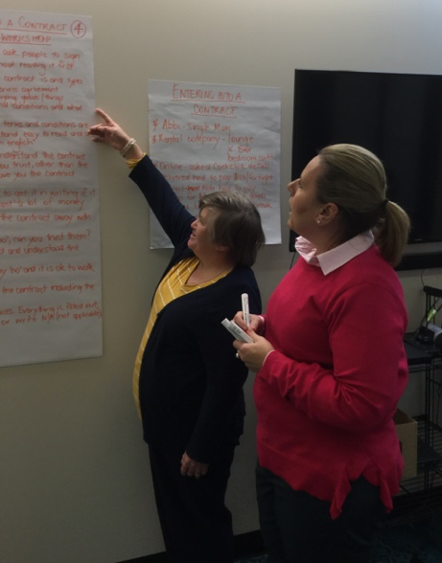

3. Having enough time to get to know each other at the outset to:
•build trust
•learn how people like to work
•know how to best support each other
•work well as a team.

