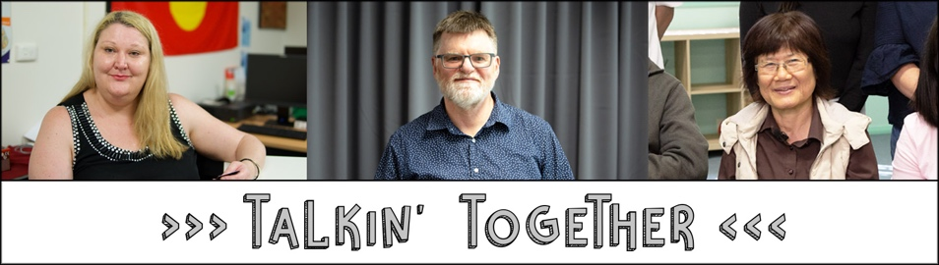
TnT Participant Outcomes
(from independent TnT evaluation, Dec 2018)

Partnership | Positive Outcome | Challenges
Council for Intellectual Disability | •Learned about how to make a complaint, types of scams, and how to get help, including from Fair Trading  •Feel empowered and inspired by the peer facilitators leading the workshops – “I have a disability and I can do this too”  •Other outcomes for individual participants include confidence to make a complaint and reinforcing knowledge | •People have learned not to complain because they fear they may lose services  •Complaints processes can be difficult to access
Being | •Learned about how to read contracts, check contract terms and conditions, use the Fair Trading checklist before signing a contract, and how Fair Trading can help  •Other outcomes for individual participants include sharing information with friends | •The lack of services in some locations means people feel there is not an alternative to a poor quality service or fear that they will have no service if they complain  •People with psychosocial disability can question themselves, so may not feel confident to make a complaint
Community Disability Alliance Hunter | •Connected with people with disability (where may not have done so before)  •Received support to access assistance with primary needs  •Increased understanding of how to make the most of an NDIS plan e.g. the right to change coordinator supports and providers, self-manage (in some cases, this information has been shared through community organisations who attended workshops) | •Some people haven’t got an NDIS plan yet so aren’t ready for the message about their right to complain  •Some people are struggling with their NDIS plans so focused on this rather than consumer rights education  •People may not complain because of distrust of government, previous negative experiences with government processes or fear in a small community that everyone will know your business  •Written complaints process is inaccessible
Diversity and Disability Alliance/ Ethnic Community Services Co-operative | •Learned about their rights  •Increased confidence to stand up for their rights  •Outcomes for family members and carers included identifying potential opportunities for their children to have a role contributing to their community like the peer facilitators | •People may not be familiar with the concept of consumer rights or have trust in government processes because of experiences in their home country  •People may be reluctant to complain  •Reading contracts in a second language is difficult

