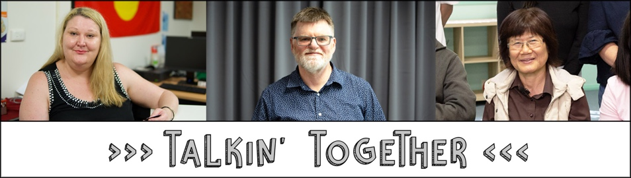
TnT Design & Delivery models
(from independent TnT evaluation, Dec 2018)

Partnership | Design | Delivery | Why this approach?
Council for Intellectual Disability | •A series of four workshops –one for each topic (scams, making a complaint, entering a contract, hiring a service; hiring a service and contracts also combined in one workshop)  •Spinning wheel and videos to engage participants and reinforce messages  •Examples of scam emails  •Peerfacilitator told personal stories  •Role plays to share information | •Delivered sessions at organisations they knew  •One peer facilitator leads each workshop  •Fair Trading facilitator prompts peer facilitator and supports role plays  •CID worker provides support  •Resources: contact list for when scammed, how to make a complaint checklist, other Fair Trading resources | •Script was difficult for peer facilitators to remember, so changed to Fair Trading facilitator prompting peer facilitator, which worked better  •Delivery style designed to
Being | •In main locations: a series of four workshops –each covering a different topic  •In more remote locations: one-off workshops, covering one or more topics  •Design centred on purposeful storytelling  •Game to support understanding  •Spinning wheel to reinforce information  •Role plays to share information in some locations | •Worked with some existing groups  •Peer facilitator/s lead workshop  •Fair Trading facilitator provides support with information on consumer rights  •Being worker provides information and prompts as needed  •Delivery style varied by location and number of peer facilitators  •Resources: contract checklist, merchandise, cards with tips | •Decided on one topic per workshop as easier for peer facilitators to remember  •Delivery style suited to audience, with some differences to suit peer facilitators –some of whom were experienced facilitators  •Needed to be mindful of language used and stories shared to prevent triggering for peer facilitators and participants
Community Disability Alliance Hunter | •Tania’s Top Tips on Tuesdays (Facebook video posts) and Suzy’s Super Suggestions on Sundays  •Yarning circles/ NDIS gatherings –with facilitators sharing their experience with the four topics (e.g. hiring a service)  •Follow-up supports for participants | •Initially connecting through community networks, NAIDOC events and sharing merchandise  •Two peer facilitators generally at each gathering  •Holding gatherings at Aboriginal organisations, working with Ability Links and NDIS Local Area Coordinators to support participants  •Providing food and transport to gatherings  •Later re-focused on peer-to-peer in-depth support, going to meet people where they are | •Need to engage Aboriginal organisations and build long-term relationships  •Attract interest through events, flyers and merchandise  •Informal conversation approach suited to
Diversity and Disability Alliance/ Ethnic Community Services Co-operative | •All four topics covered in one session  •Scripted  •PowerPoint with pictures  •Message “Never give up” | •Two peer facilitators at each session (with a back-up if needed)  •Peer facilitators each have scripted sections of the workshop to deliver and are able to deliver as suits them  •Fair Trading facilitator asks questions and answers audience questions  •Resources: Fair Trading information sheets at some workshops, SkimGuard (very popular) | •Peers each felt comfortable with their scripted sections  •Having multiple peer facilitators and people to provide back-up helps to manage workload

